MED D - Verifying Enrollment, Eligibility and LIS in MARx

Overview
Viewing Medicare Eligibility Information in MARx
Interpreting Medicare Eligibility Information in MARx
Accessing Client-Specific Eligibility Information in MARx
Interpreting Client-Specific Eligibility Information in MARx
Log Activity
Related Documents

Description: This document provides guidance for verifying Enrollment, Eligibility and LIS in MARx

Overview
The Medicare Advantage Prescription Drug Eligibility System, also known as MARx, will assist MED D Customer Care Representatives (CCRs) in verifying:
- Part D enrollment and eligibility for Medicare eligible beneficiaries
- Low income subsidy information for Medicare eligible beneficiaries

Along with other systems such as PeopleSafe, FACETS and Fazal, CCRs will utilize MARx to answer and resolve beneficiary eligibility inquiries.

Maintaining access to MARx:
- Periodic password changes are not required. CCRs will be required to log into their accounts every 60 days to keep them active.
- An inactive account will be disabled by the system and the CCR will need to reset their password using an IDM self-service procedure or by contacting the MAPD Help Desk.

This document will assist CCRs in the following MARx functions:
- Accessing Medicare Eligibility information
- Accessing Part D Client-Specific Information

Notes:
- To request access for MARx or to change the password, refer to the MED D - Accessing MARx work instruction for guidance.
- If no access to MARx and need assistance verifying information in MARx, contact the Senior Team. Refer to MED D - When to Transfer Calls to the Senior Team.

Top of the Document

Viewing Medicare Eligibility Information in MARx
Under the Eligibility menu of MARx, CCRs will be able to view general Medicare plan eligibility information for the specified beneficiary.

CCRs will be able to verify Medicare eligibility such as:
- Part A and B eligibility used to determine eligibility for Part D coverage
- Part D eligibility
- Current Enrollment in a Part D plan
- Effective Date of the beneficiary’s enrolled Part D plan
- Number of uncovered months used to determine Late Enrollment Penalty, if any.
- Verification of Low Income Subsidy, if any

Note: If no access to MARx and need assistance verifying information in MARx, contact the Senior Team. Refer to MED D - When to Transfer Calls to the Senior Team.

Follow the steps below to locate general Medicare eligibility information in MARx:
Step | Action
1 | Log into MARx. Refer to MED D - Accessing MARx.  Result: The Medicare Advantage Prescription Drug (MARx) User Security Role Selection screen will display.
2 | Click on the Beneficiaries link.  Result: The Beneficiaries: Find (M201) screen will display.
3 | Click on the Eligibility link.  Result: The Beneficiary: Eligibility (M232) screen will display.  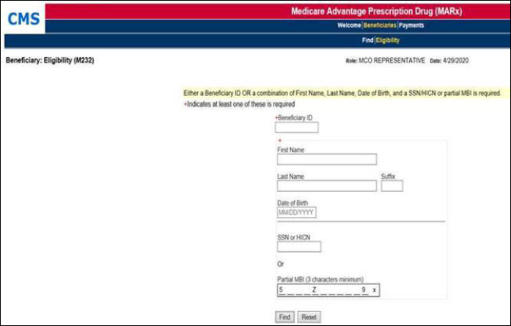
4 | In the Beneficiary ID # field, type the beneficiary’s Member Beneficiary Identifier (MBI).  OR  Enter the following required fields:  - First name (or first letter of first name)  - Last name (or first six (6) letters for last names longer than six letters)  - If a beneficiary has either an apostrophe or a hyphen in their last name, the apostrophe, hyphen, or a space must be entered in order to match and return the MBI.  - If a beneficiary has a suffix (Example: Sr., Jr., III, or IV) after their last name and their last name has fewer than six (6) characters, the user must enter the suffix in the three-digit suffix entry box, without any punctuation, in order to match and return the MBI. The suffix is not required if a beneficiary’s last name consists of six or more characters.  - Date of birth  - HICN, or beneficiary’s Social Security number, or a portion of the MBI (minimum of three (3) characters)  Notes:  - The beneficiary’s Part D prescription benefits ID number is not accepted in MARx.  - The CCR must use the beneficiary’s MBI found on the beneficiary’s Medicare ID card.
5 | Click on the Find button.  Result: The Beneficiary: Eligibility (M232) screen will populate with available Medicare Eligibility information.  Note: If an invalid MBI number is entered, the message Beneficiary Not Found will display.  - Refer to the Interpreting Medicare Eligibility Information in MARx section of this work instruction for detailed information on this screen.

Top of the Document

Interpreting Medicare Eligibility Information in MARx
The screenshot and Table below will assist the CCR to interpret the information found on the Beneficiary: Eligibility (M232) screen:

Note: Although current information on file with CMS is viewable on the Beneficiary: Eligibility (M232) screen, an audit history of this information is only accessible on the Beneficiary Snapshot (M203) screen.

The Part D Enrollment section has been removed because the Enrollment section now indicates whether the beneficiary is enrolled in a drug plan.

Screen Details | MARx Screen  (M232)
- Claim Number  - MBI Number  - Name  - Birth Date  - Date of Death  - Sex  - Address  - Current State  - Current County | 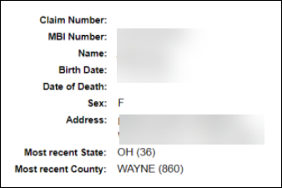
- Contract ID *
- Plan Benefit Package (PBP)*
- Plan Type Code & Description
- Start (Effective) Date
- End (Termination) Date
- Drug Plan

*Displays only for two most recent enrollments.

Updates: This section will also display:
- Beneficiary’s entire enrollment history with most recent enrollment as the top row
- Consecutive enrollments in two different PBPs under the same contract
- Enrollment in a PACE plan

Note: If a Non-SilverScript (S5601) OR Blue MedicareRx (S2893) Contract ID is displayed, advise the beneficiary:

- I see that you are enrolled in another plan starting on <date>. You may contact Medicare about information on that specific plan.
- If you would like to contact Medicare, you can call:

1-800-MEDICARE (1-800-633-4227), 24 hours a day, 7 days a week
TTY users call: 1-877-486-2048

Note: If the caller agrees, cold Transfer them to Medicare.

- Medicare Part A  - Medicare Part B  - Start (Effective) Date  - End (Termination) Date  - (Entitlement) Option  - E = Eligible  - Y = Yes | 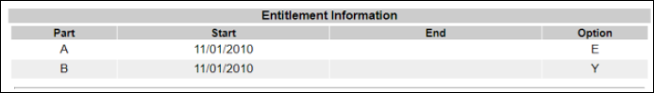
- Part D Start (Effective) Date  - Part D End (Termination) Date  - Medicare Plan Enrollment Ineligibility Periods Due to Incarceration  - Medicare Plan Enrollment Ineligibility Periods Due to Not lawfully Present | 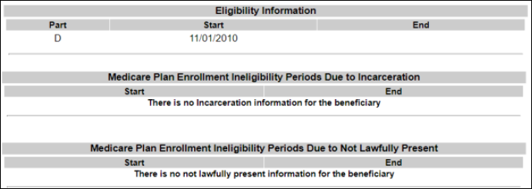
- Start Date (of Uncovered Months)  - Indicator:  - C = Cumulative  - I = Incremental  - R = Reset to 0  - Number (of Uncovered Months) found by BEQ  - Total Number (of Uncovered Months)  - Date/Time Stamp (of BEQ-discovered Uncovered Months) | 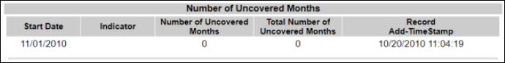
- Employer Subsidy Start (Effective) Date  - Employer Subsidy End (Termination) Date | 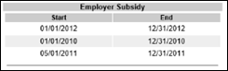
- CARA Status Start Date  - CARA Status End Date | 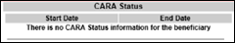
- LIS SEP Election Type Code last used date | 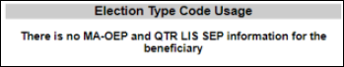
- LIS Subsidy Start (Effective) Date
- LIS Subsidy End (Termination) Date
- Premium Subsidy Level (100%)
- Co-Payment Level (1-3)
- Subsidy Source (SSA LI Applicant, Deemed)

Top of the Document

Accessing Client-Specific Eligibility Information in MARx
Under the Find menu of MARx, the CCR will be able to view Client-Specific information for the Contract ID# requested during the registration process.
- This section is useful for viewing the Audit History of a beneficiary’s eligibility information such as:
  - Changes in Low Income Subsidy levels during the beneficiary’s enrollment in either of the plans listed below.

Contract ID | Client Name
S5601 | SilverScript Insurance Company LLC, includes:  - SSI - Individual Enrollees (Client Code x9110)  - SSI - Employer Group Waiver Plan Enrollees (Multiple Clients Codes)
S2893 | New England Joint Enterprise  - Blue MedicareRx (CT, MA, RI, VT)  - Anthem Blue Cross Blue Shield (CT, MA, RI, VT)

Note: If no access to MARx and need assistance verifying information in MARx, contact the Senior Team. Refer to MED D - When to Transfer Calls to the Senior Team.

Follow the steps below to locate client-specific eligibility information in MARx:
Step | Action
1 | Log into MARx. Refer to MED D - Accessing MARx.  Result: The Medicare Advantage Prescription Drug (MARx) User Security Role Selection screen will display.
2 | Click on the Beneficiaries link.  Result: The Beneficiaries: Find (M201) screen will display.  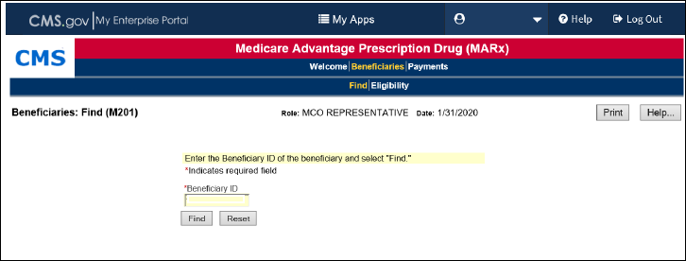
3 | In the Beneficiary ID field, type the beneficiary’s Member Beneficiary Identifier (MBI).  Note:  - The beneficiary’s Part D prescription benefits ID number is accepted in MARx.  - CCRs must use the beneficiary’s MBI found on the beneficiary’s Medicare ID card.
4 | Click on the Find button.  Result: The Beneficiary: Eligibility (M202) screen will populate with available Medicare Eligibility information.  Note: If an invalid MBI number is entered, the message No beneficiary records found for the search criteria will display.  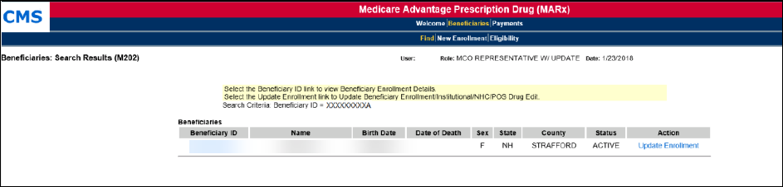
5 | Click on the hyperlinked Beneficiary ID #.  Result: The Beneficiary Snapshot (M203) screen will display in another internet browser window.  Refer to the Interpreting Client-Specific Eligibility Information section of this work instruction for detailed information on this screen.

Top of the Document

Interpreting Client-Specific Eligibility Information in MARx
This section allows the CCR to view the Audit History of a beneficiary’s eligibility information. Although current information on file with CMS is viewable on the Beneficiary: Eligibility (M232) screen, an audit history of this information is only accessible on the Beneficiary Snapshot (M203) screen.

The table below explains the information accessible on the various tabs of the Beneficiary Snapshot (M203) screen.
- Descriptions are only provided for those tabs applicable to the CCR’s workflow.
- Additional directions for using each tab can be found on applicable work instructions.

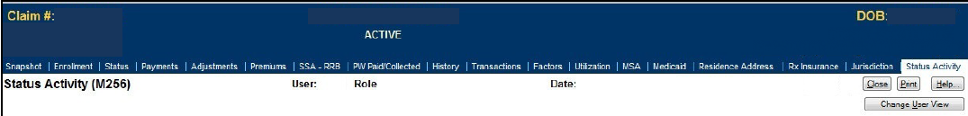

Find: Eligibility Tab | Tab Details
Snapshot  (M203) | - MBI Number  - Name  - Birth Date  - Date of Death  - Sex  - Address  Note: SSA State and County Codes have been relocated to the Status Activity (M256) tab.
Enrollment | - Contract ID  - Start (Effective) Date  - End (Termination) Date  Note: By clicking on the Contract ID in this section you can tell the active Plan ID # that should be used to access the account as well as what ID is registered with MARx if there are multiples in PeopleSafe. Enrollment details (M222)
Status | - Medicare Part A  - Medicare Part B  - Start (Effective) Date  - End (Termination) Date  - (Entitlement) Option
Payments | - Part D Start (Effective) Date  - Part D End (Termination) Date  Note: The Payment/Adjustment Detail (M215) screen is being enhanced to display the risk adjustment factor used in determining the beneficiary’s payment.  - This information is not applicable for CCR purposes and can be hidden at the user’s discretion.
Premiums | - Start Date (of Uncovered Months)  - Number (of Uncovered Months) found by BEQ  - Total Number (of Uncovered Months)  - Date/Time Stamp (of BEQ-discovered Uncovered Months)  Note: This section is vital to determining the status of an SSA/RRB Deduction request.
SSA - RRB | - Employer Subsidy Start (Effective) Date  - Employer Subsidy End (Termination) Date  - SSA Part C/D Premium Withhold Block
Rx Insurance | - CCR can see if the Beneficiary has the account registered as primary or secondary (SSI) which can affect the alternate flags on the account.  - Useful to be able to look at the information to send up to COB for assistance.
Status Activity  (M256) | - SSA State and County Codes  - Low Income Subsidy  - Number of Uncovered Months  - Health Status Flags (ESRD, MSP, etc.)  - Eligibility Status Flags (Part A, Part B and Part D)  - Incarceration  - Not Lawfully Present  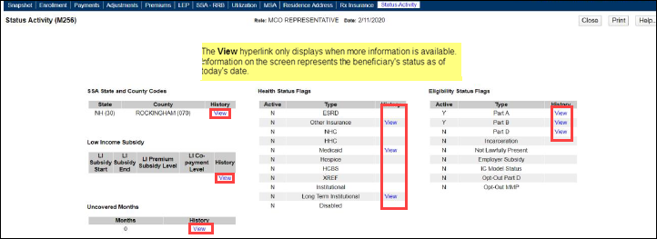  Note: The default display for this tab shows a beneficiary’s current information on file with CMS.  - A View hyperlink will display under the History column in any section that has more information available.  Example: A beneficiary’s SSA State and County Code history would be viewable on this tab.

Top of the Document

Log Activity
MARx is a Read-only system.
While CCRs are not able to document in MARx, CCRs should document their MARx findings in PeopleSafe Medicare D Inquiry tab.

Refer to MED D - Call Documentation.
Top of the Document

Related Documents
Parent SOP: CALL-0048: Medicare Part D Customer Care Call Center Requirements-CVS Caremark Part D Services, L.L.C.
Abbreviations/Definitions: Abbreviations / Definitions

Top of the Document
Not To Be Reproduced Or Disclosed to Others Without Prior Written Approval
ELECTRONIC DATA = OFFICIAL VERSION - PAPER COPY = INFORMATIONAL ONLY

